**10-23 Notes**

APIs and Geospatial Data Visualization

Goals:

By the end of this lesson, you will be able to:

* Use the Geoapify API to obtain information about geographic areas.
* Use the Census API wrapper.
* Explain the concept of rate limits and the importance of creating test cases before running large scripts.
* Dissect new API documentation.

**Restaurants solution:**

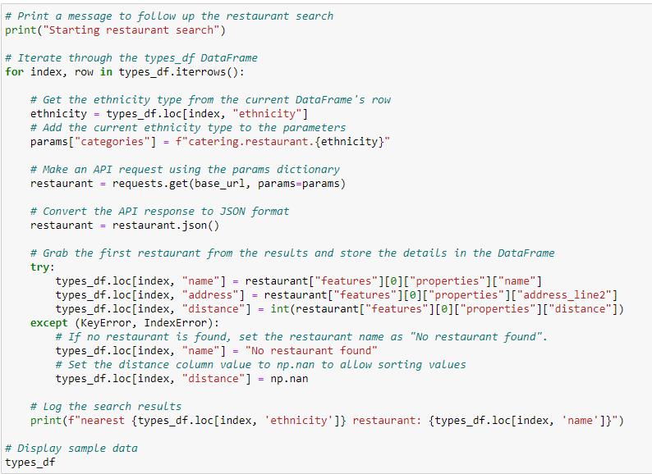

^ throwing in print(row["ethnicity"]) below where you get the ethnicity makes the result have a line stating the ethnicity between each record

